* **Title for Intro Slides - red slides**
* **Summary for my slides - pink slides**

**Intro slide - red**

* **1 & 2 Title**s

**Pink slide - 1**

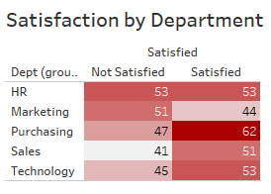

**0 - HR**

**7 - Marketing**

**15 - Purchasing has the biggest difference between Satisfied and Not Satisfied count**

**10 -Sales**

**8 - Technology**

* Marketing has the least amount of “Satisfied” Employees - 44
* Purchasing has the most amount of “Satisfied” Employees - 62
* Purchasing also has the biggest difference between the Satisfied and Not Satisfied count
* HR has the same amount of “Satisfied” Employees as “Not Satisfied” Employees

**SUMMARY OF PINK SLIDE - 1**

So generally, this shows that Purchasing is the best industry to be in if you want to be happy about your career while Marketing can be the least satisfying industry to be in. The top three industries based on employee satisfaction are Purchasing, Technology & Human Resources.

**Pink Slide - 2**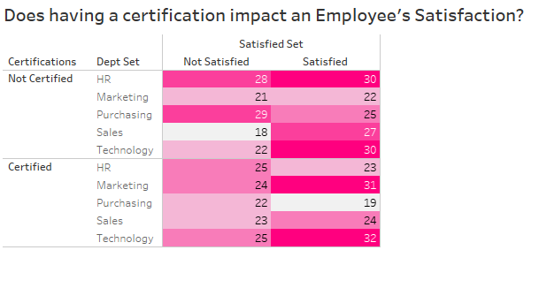

* Having a certification impacts the Technology department “Satisfied” level the most
* Generally, having certifications positively impacts the “Satisfied” count in all departments
* The Purchasing department has the most amount of “Not Satisfied” and “Not Certified” employees
* HR was negatively impacted by having “Certified” employees
* Marketing and Technology had the biggest positive impact on Satisfaction from having “Certified” employees

**SUMMARY OF PINK SLIDE - 1**

Having certifications in a technology based industry will assure that the employee has put in effort towards building their skills and in doing so will gain more satisfaction from their hard work. Human Resources had a negative impact by having more certified employees ,perhaps, simply due to the fact that generally, this career requires managing more people. Having certifications in the Marketing and Technology industries had the most positive impact on the satisfaction of employees.

**In Conclusion Slide - red**

* **Title &**
* **First Two Bullets**